Puzzle Design Challenge

Autobiography

My name is Devin Murray. I am a freshman at Southeast Raleigh High School and I am looking forward to attending college. Outside of school, I like to sleep, eat, and play soccer. I made my school’s varsity soccer team, but I wasn’t a starter. The season is over, but we almost made it into the playoffs. I also like to do math and science; those are my favorite two subjects in school. Next semester, I have Math II Honors! I am really looking forward to that.

Puzzle Design Challenge Brief

Client Fine Office Furniture, Inc.

Target Consumer Ages: High school aged

Designer Devin Murray

Problem Statement
A local office furniture manufacturing company throws away tens of thousands of scrap ¾” hardwood cubes that result from its furniture construction processes. The material is expensive, and the scrap represents a sizeable loss of profit.

Design Statement
Fine Office Furniture, Inc. would like to return value to its waste product by using it as the raw material for desktop novelty items that will be sold on the showroom floor. Design, build, test, document, and present a three-dimensional puzzle system that is made from the scrap hardwood cubes. The puzzle system must provide an appropriate degree of challenge to high school students.

Criteria
- The puzzle must be fabricated from 27 – ¾″ hardwood cubes.
- The puzzle system must contain exactly five puzzle parts.
- Each individual puzzle part must consist of at least four, but no more than six hardwood cubes that are permanently attached to each other.
- No two puzzle parts can be the same.
- The five puzzle parts must assemble to form a 2 ¼″ cube.
- Some puzzle parts should interlock.
- The puzzle should require high school students an average of ______ minutes/seconds to solve. (Fill in your target solution time.)

Brainstorming Possible Part Combinations (Activity 4.1a Puzzle Part Combinations)

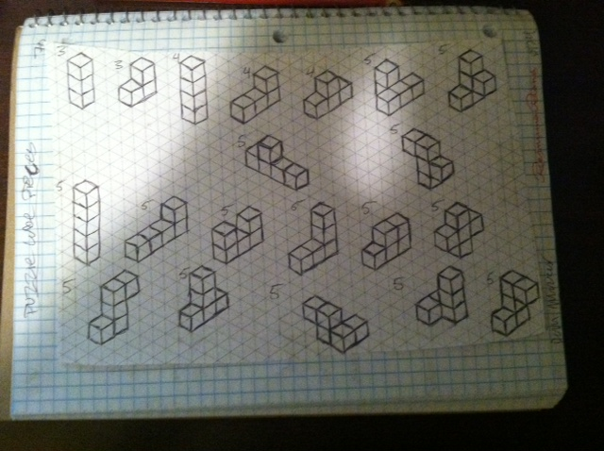

Isometric sketches of two possible complete Puzzle Cube designs

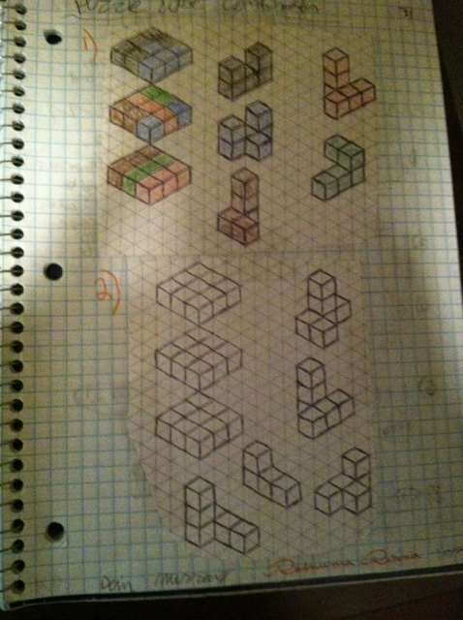

Justification of your chosen Puzzle Cube design solution

I chose the solution that is colored because I forgot how to solve the other one. Since I was already behind, I used the first combination that I created. It is actually kind of hard to solve, but it is easy to solve once you know how to solve it.

Multi-view sketch, fully dimensioned of each of the five puzzle parts in your chosen design (Activity 4.1b Graphical Modeling)

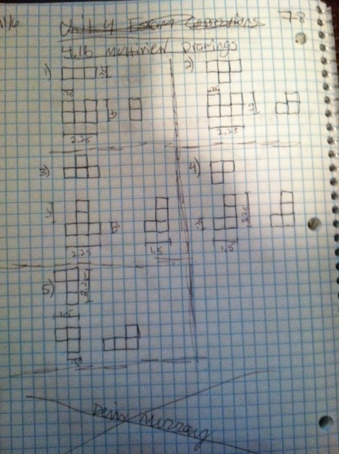

CAD Drawings

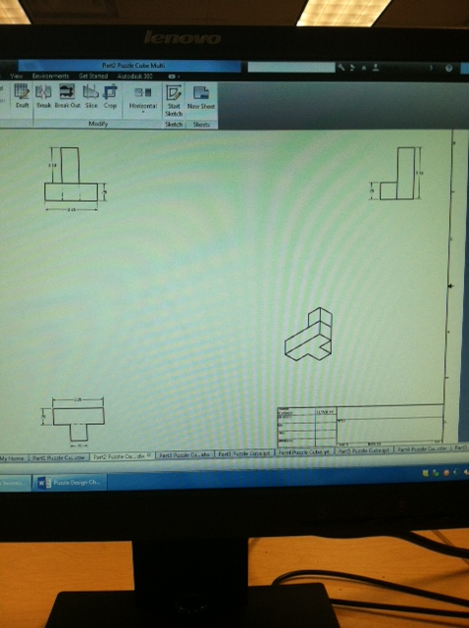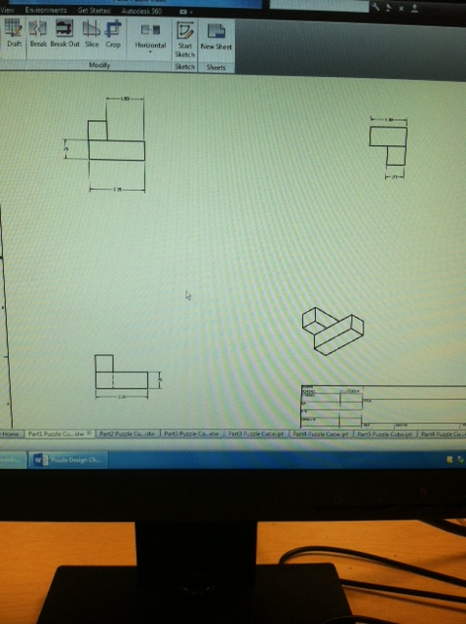
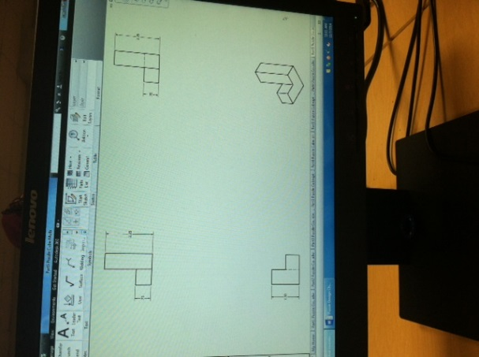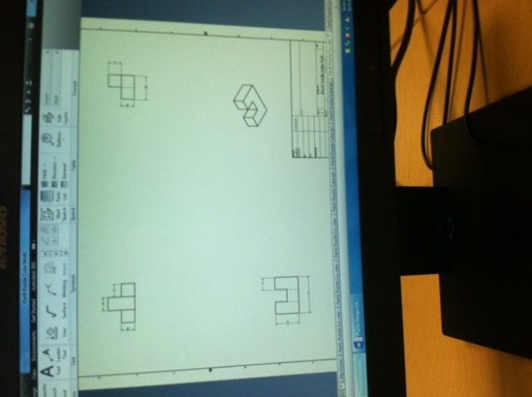
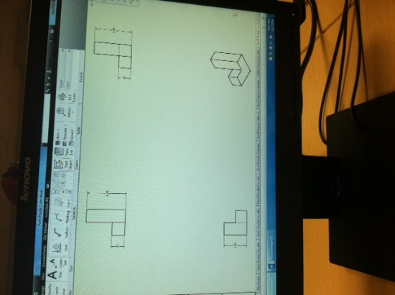
Drawing Review Comments from a Classmate

“The puzzle cube pieces and combination that you used is very unique and is challenging to solve. All of your sketches are neat and look like they are correct. One thing that I would change, though, is adding more inverted cubes to the pieces to make it more challenging to solve”

- Nile Hargrove

Image(s) of your building process and puzzle prototype.
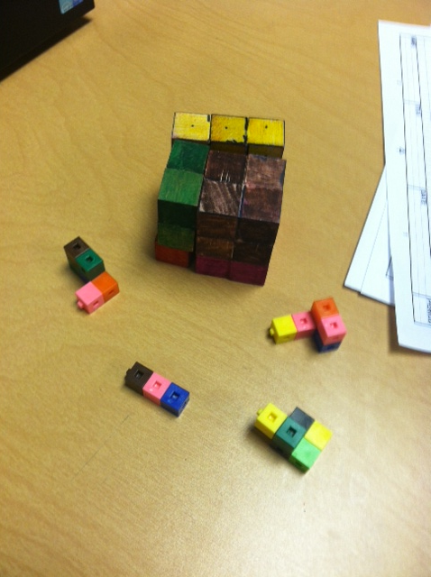

Physical Model Of Puzzle Cube

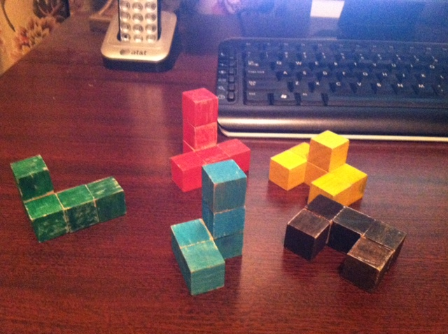
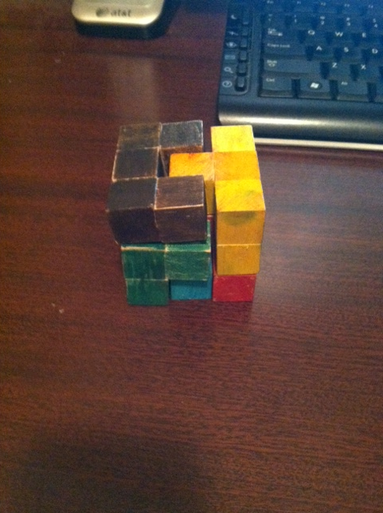
Statistics of Solution Time
Person | Time #1 | Time #2 | Time #3
Dad | 3 min 43 sec | 1 min 22 sec | 23 sec
Mom | 3 min 42 sec | 2 min 14 sec | 39 sec
Younger SIster | 4 min 16 sec | 3 min 3 sec | 57 sec
older sister | 4 min 8 sec | 3 min 1 sec | 21 sec
grand father | 3 min 14 sec | 2 min 14 sec | 26 sec
grand  mother | 3 min 45 sec | 2 min 1 sec | 1 min 3 sec
Caiden  (Friend) | 7 min 52 sec | 4 min 56 sec | 1 min 23 sec
jacob  (friend) | 10 min 9 sec | 3 min 38 sec | 39 sec
Daniel  (friend) | 2 min 33 sec | 29 sec | 24 sec
Grand Father | 6 min 42 sec | 2 min 11 sec | 37 sec

Summary of Test Results
My puzzle cube meets the requirements of 5 pieces, pieces contain no more than 6 pieces and no less than 4 pieces, and it forms a cube. The test results show that the puzzle cube is challenging enough, but not too challenging. Once people solved it, they got it faster.

Possible Changes
Some changes that I know I could make to improve this puzzle cube are to make the cube more challenging by adding more inverted cubes to the pieces. I figured out that the more inverted cubes there are on a piece, the more difficult the puzzle becomes to solve.

